**Question 1**

**Find out the mail servers of the following domain:**

**Ibm.com**

**Wipro.com**

Ans- **ibm.com mail server**

Command used- nslookup

Set type=mx

[www.ibm.com](http://www.ibm.com)

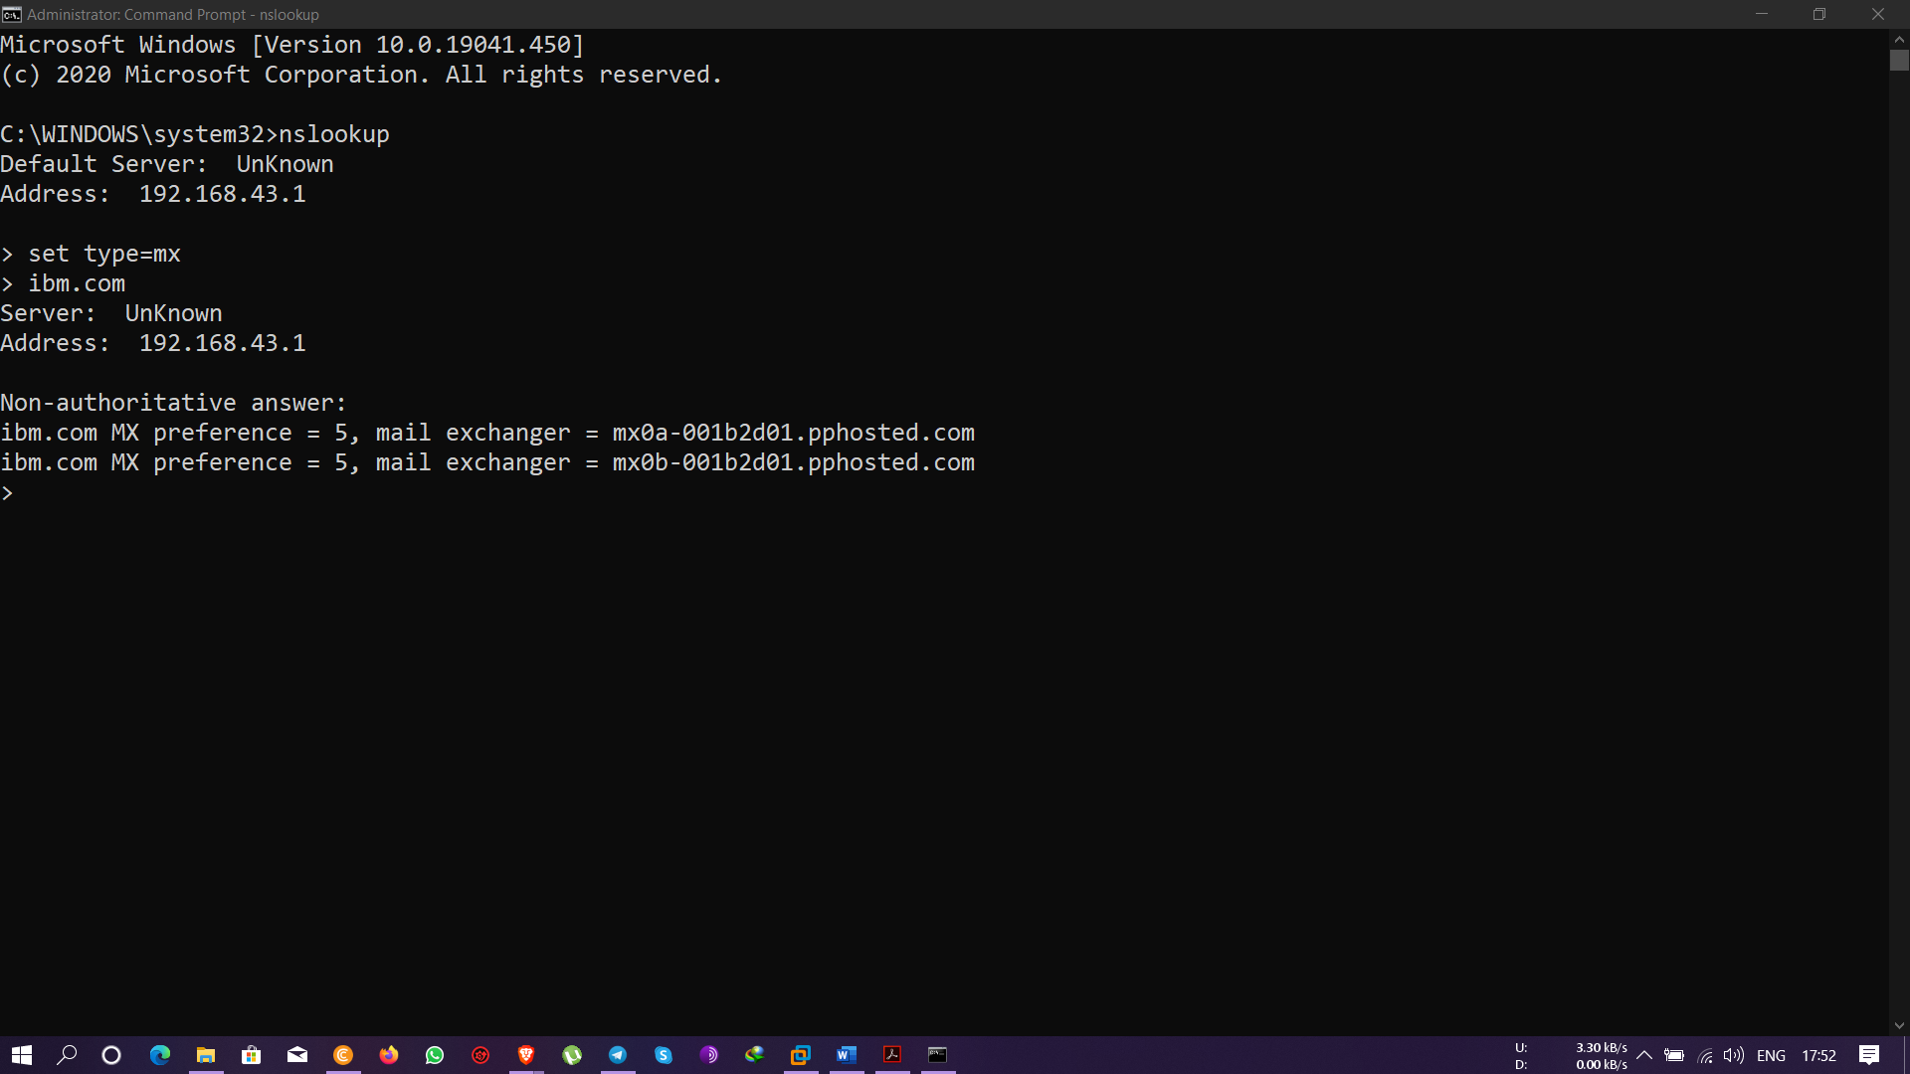

**Wipro.com mail server**

Command used- nslookup

Set type=mx

www.wipro.com

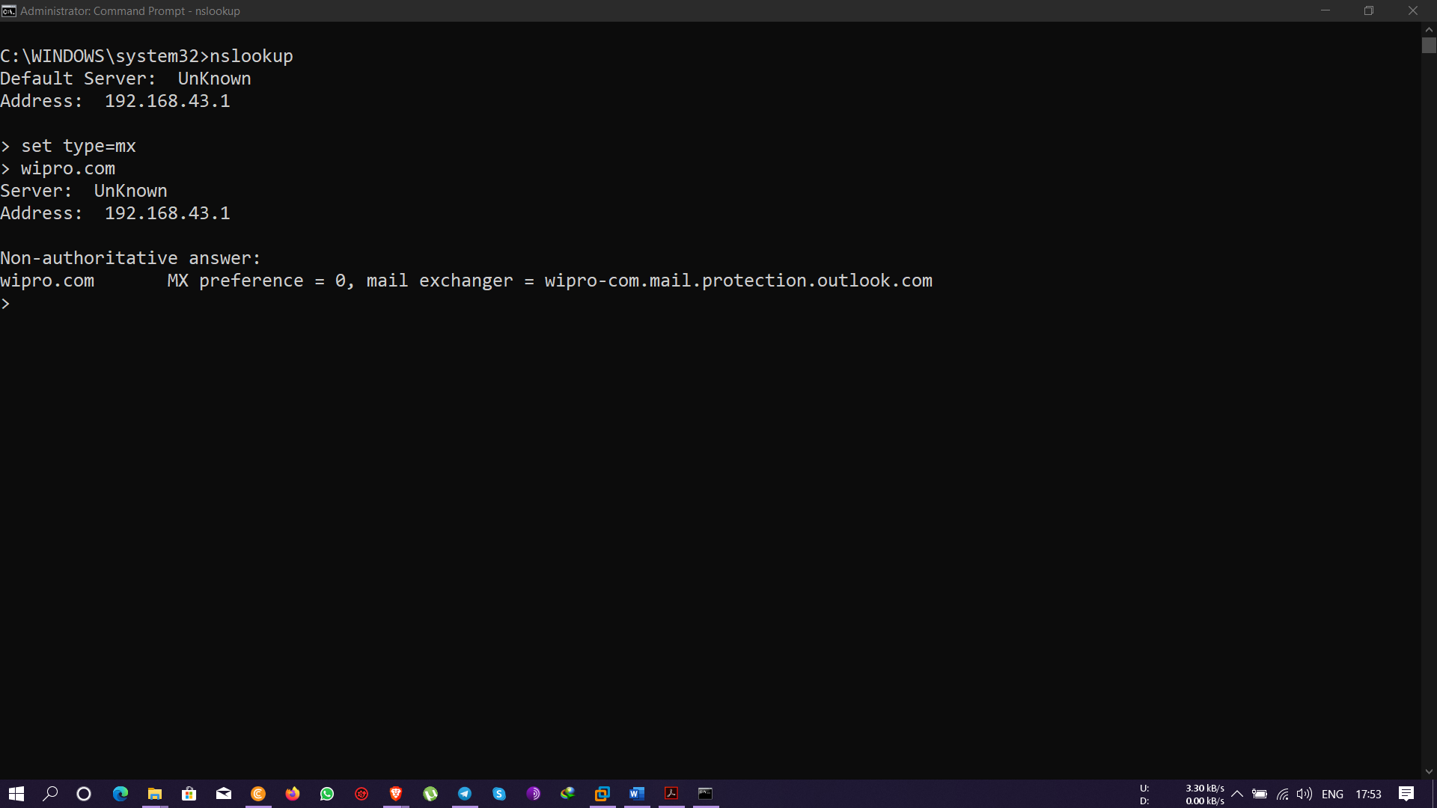

**Question 2**

**Find the locations, where these email servers are hosted?**

Ans- **ibm.com** email server location tracked by using website **check-host.net** and details acquired using-

mx0b-001b2d01.pphosted.com

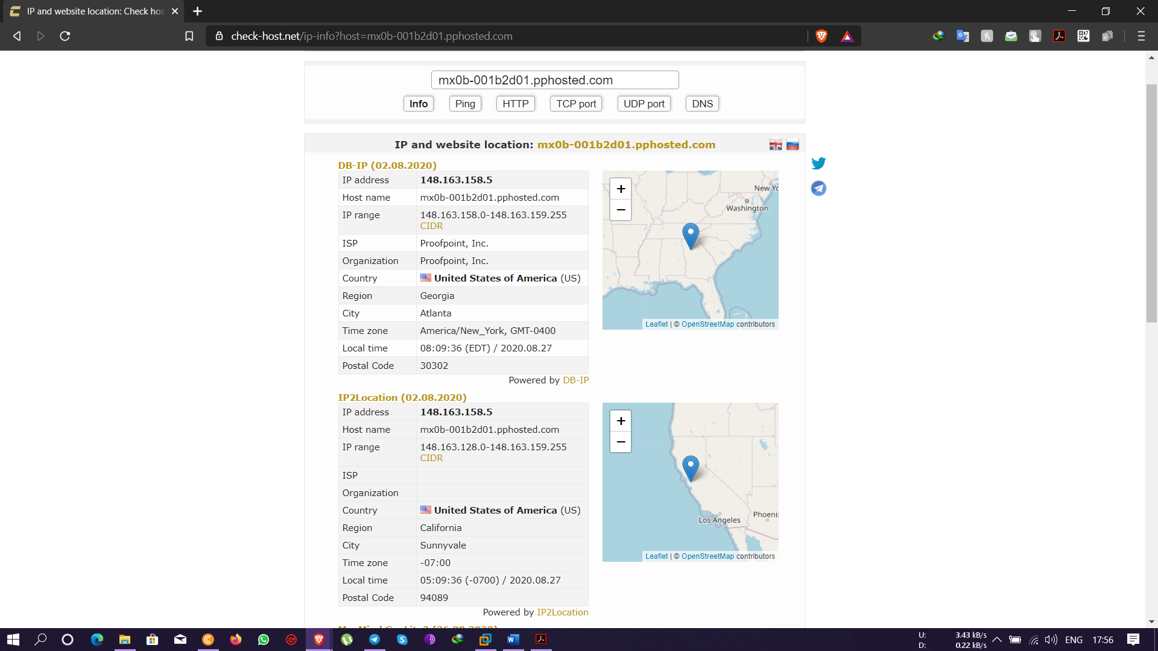

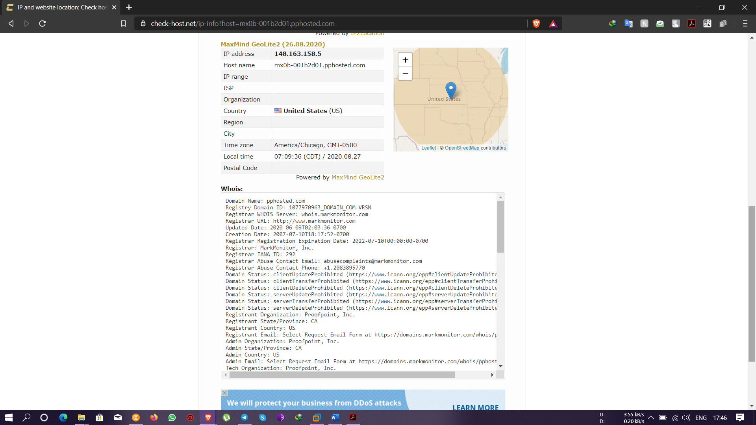

**Wipro.com** email server location tracked by using website **check-host.net** and details acquired using-

wipro-com.mail.protection.outlook.com

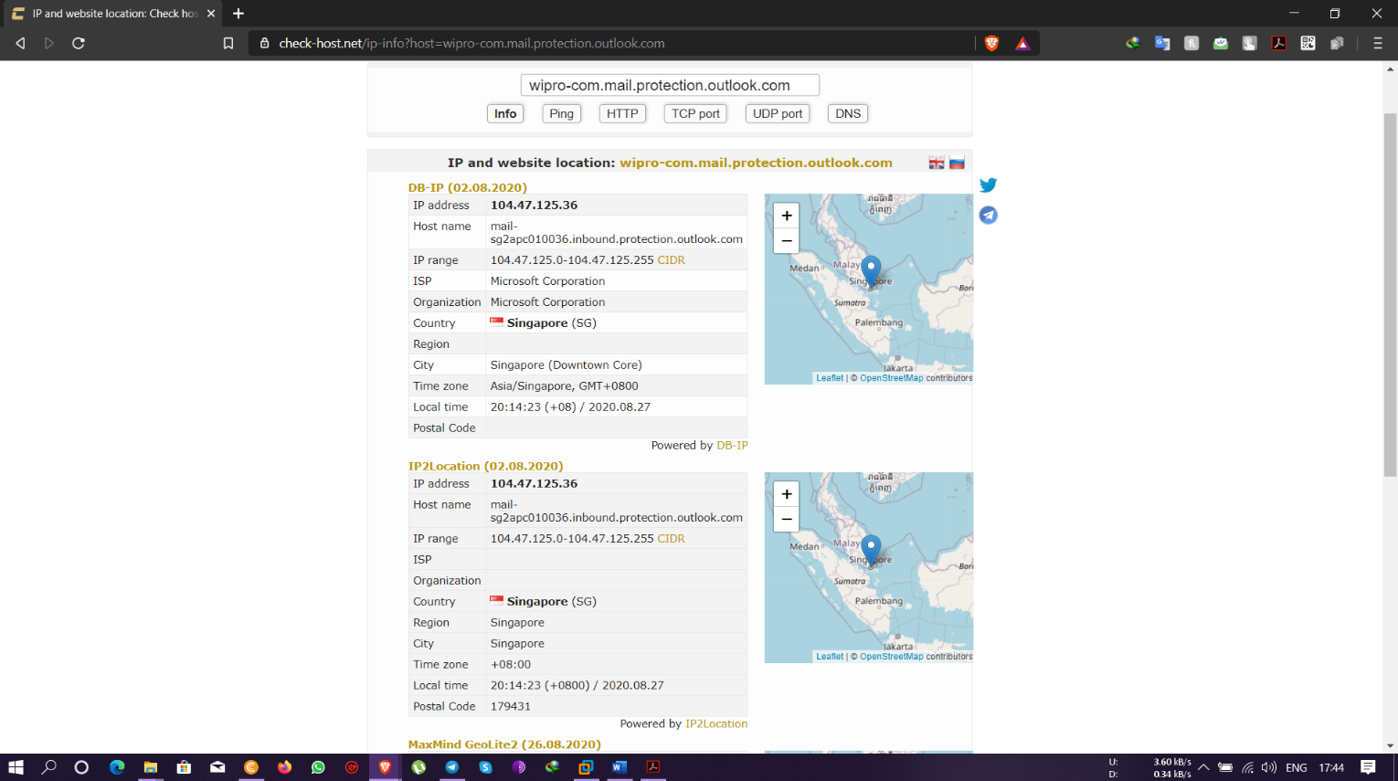

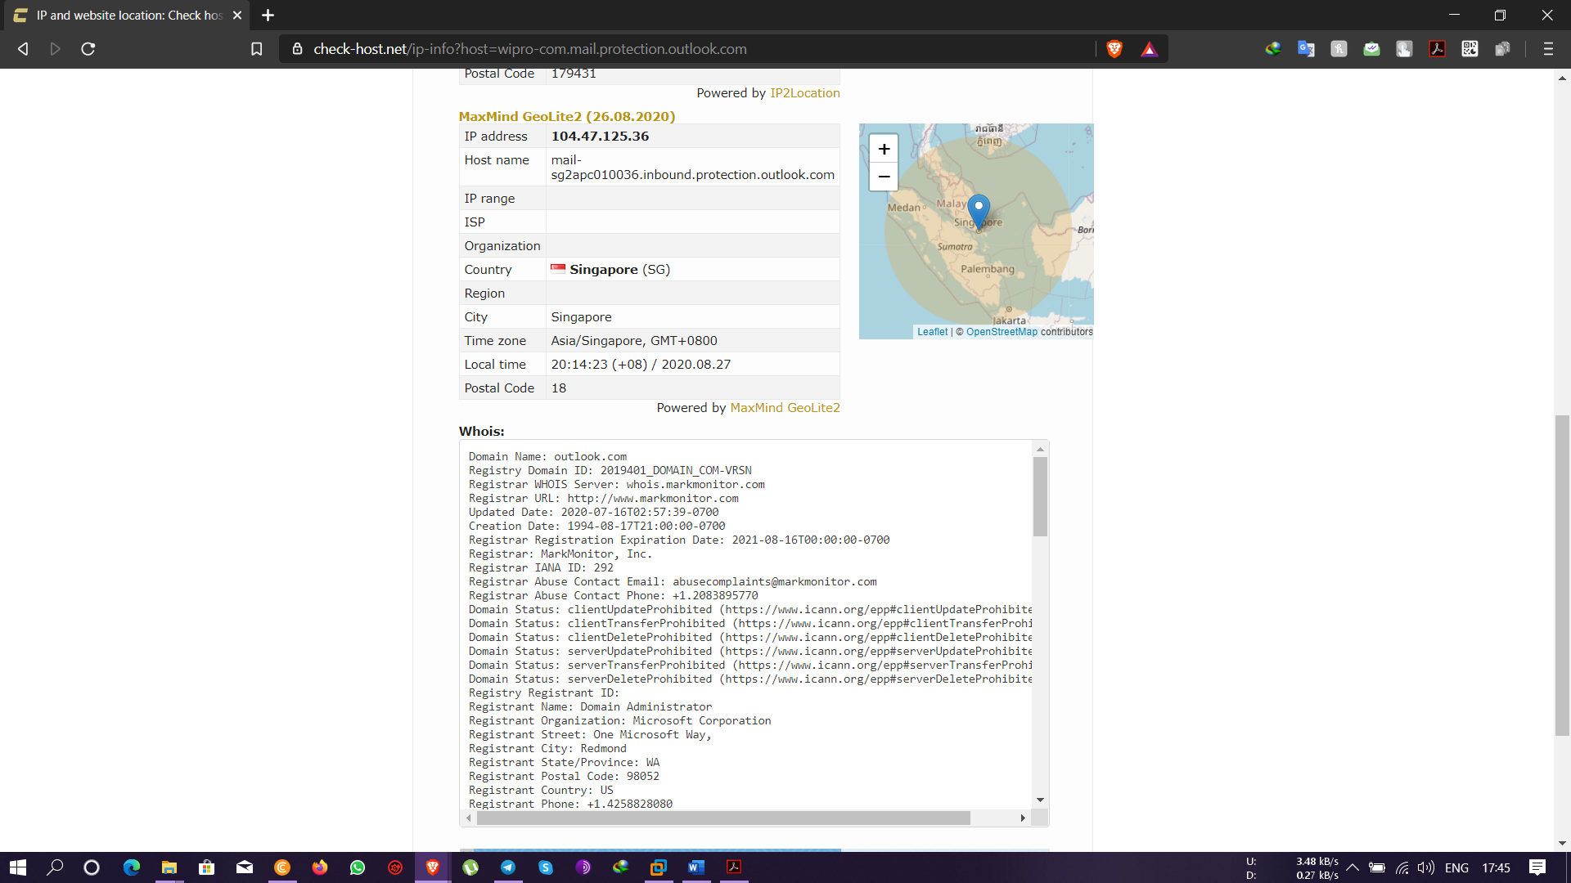

**Question 3**

**Scan and find out port numbers open 203.163.246.23**

Ans – scanned using the **nmap** command - **nmap -Pn -p1-65535 203.163.246.23** and found that all ports are filtered.

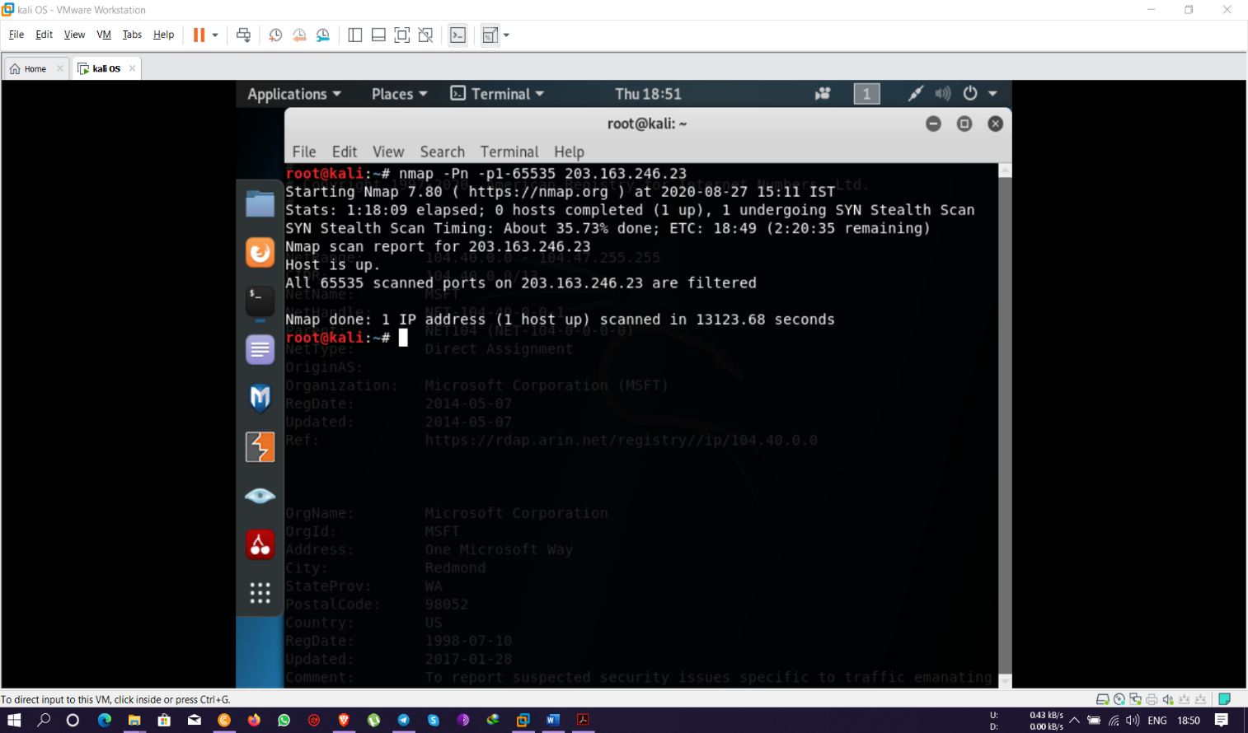

**Question 4**

**Install nessus in a VM and scan your laptop/desktop for CVE.**

Ans- installed **Nessus** in VM on windows server machine and run a scan on my local machine with IP- 192.168.43.169/24 and the scanned results are as in the images below-

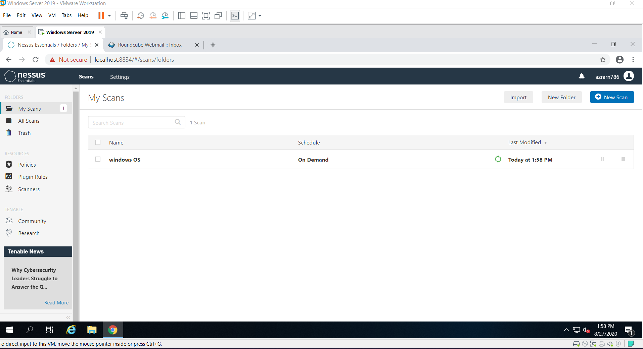

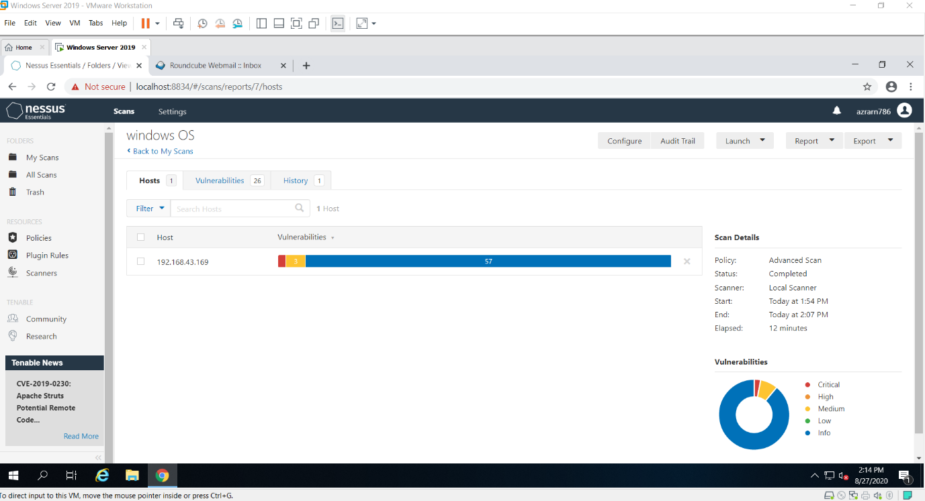

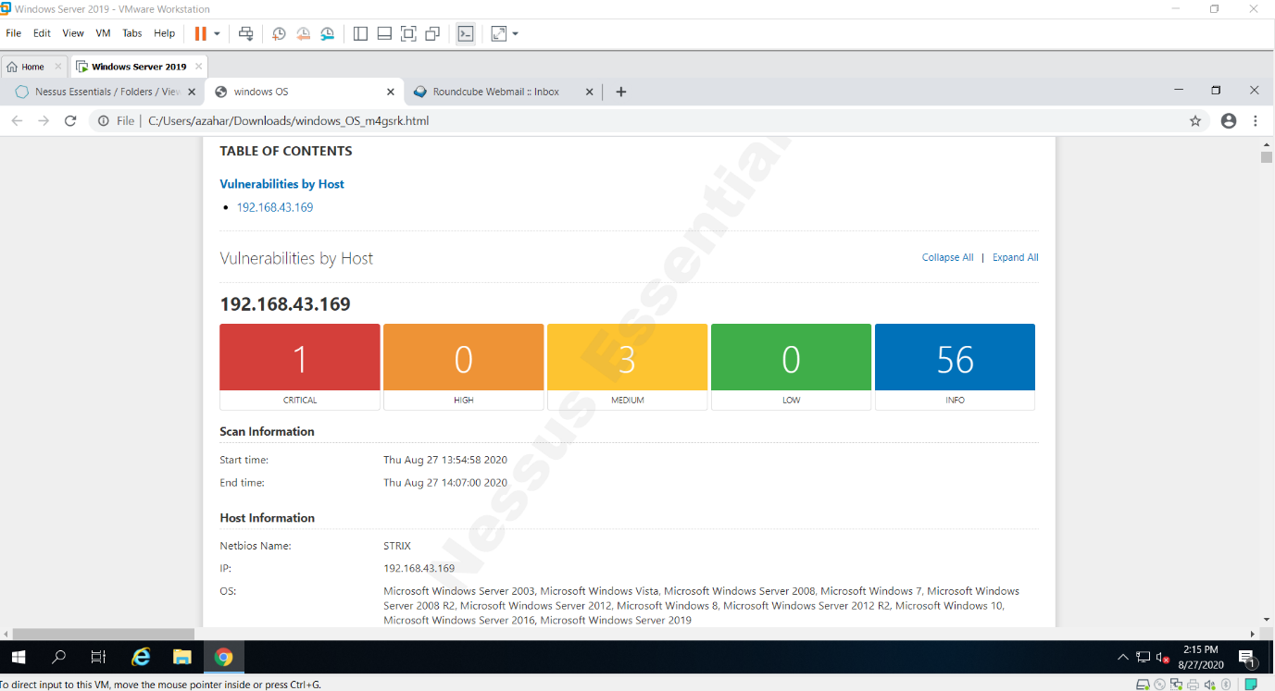

Solution recommended –

